**F A I R P L A N E**

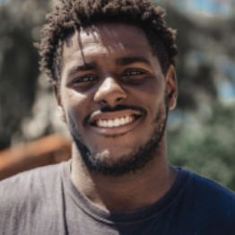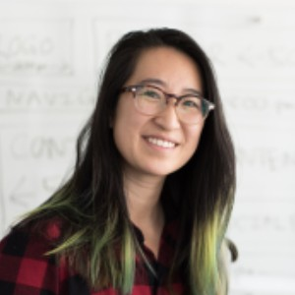

Guided city tours

**Based on ten customer interviews and observations from the Fairplane Guided City Tours team**

Claudia Larmon

Menaka Mahajan

Jerome Phillips

Alejandro Flores

Emma Sato

# Entice

**SCENARIO**

**Gas Leakage Monitoring & Alerting System For Industries**

How does someone initially become aware of this process?

# Enter

What do people experience as they begin the process?

# Engage

In the core moments in the process, what happens?

# Exit

What do people typically experience

as the process finishes?

# Extend

What happens after the experience is over?

**Steps**

**World wide solution**

**Current trends**

**Do develop more**

**Is the system is scalable**

**Is the systemis reliable**

**Testing process**

**Monitor the gas and temperature level**

**Finding the toxic gas released**

**BrainstormMethod**

**Took the survey of recent accidents**

What does the person (or group) typically experience?

Customer has recognizes the important of preventing hazards

The customer will refer and discuss the ideas and their opinion

The customer must be aware in the released toxic acid and its level

The system will monitor and give an update the humidity , temperature and gas level

Does the testing process met all the requirements.

The system requirements are reliable

The system requirements are scalable

To develop and upgrade the project for more uses

Thus the system compete the current technology

To add the word wide feature and help to use for all industries

## Interactions

Sollution worldwide

Testing

System popularity among the space

Outcome of the overall process

Process management and condition

Control management

Bugging and debugging of the system

Output of the system is realiable

Eco friendly and easy to manage

System space is efficient

System access time is quicker and faster

Is the platform is open source

The software platform is realiable

Eco friendly

Is the system iseasy to use

It is very secured and safety for implementation

What interactions do they have at each step along the way?

Power consumption is less

**People:** Who do they see or talk to?

**Places:** Where are they?

**Things:** What digital touchpoints or physical objects would they use?

## Goals & motivations

Helps me to understand the sensor data is visualized in the web application

Help me to avoid the Fire accidents in industry

Help me see what I could be doing next

Help me see what I've done before

Help me to understand how to connect IOT devices to the Watson IOT platform and Exchanging the sensor data

Help me make sure I don't forget about my Project Because I have learn many things

Help me understand what this Project and concept

Help me feel confident that my purchase is finalized and tell me what to do next

Help me feel confident and make me more knowledgable person

Helps to explore python library and gain the knowledge of IBM

Help me commit to going on this project of gas leakage

Helps me to understand the knowledge of IOT platforms

Help me if in any area gas leakage is detected the admins will be along with location

Help me have gas sensors will be integrated to moniter the gas leakage

This project helps the Industries in monitoring the emission of harmful gases

At each step, what is a person’s primary goal or motivation? (“Help me...” or “Help me avoid...”)

## Positive moments

What steps does a typical person find enjoyable, productive, fun, motivating, delightful, or exciting?

Control the accident

### It's reassuring to red reviews written

Control harzard and accident

Customer satisification and requirements

Excitement about the purchase

### ("Here we go!")

Save the gases

Cost is efficient and ecofriendly

Safety and security

Confident and best solution for accident prevention

Satisification

## Negative moments

What steps does a typical person find frustrating, confusing, angering, costly, or time-consuming?

Process was difficult

Gas leakage

### People express a bit of fear of commitment at this step

Trepidation about the purchase

### ("I hope this will be worth it!")

Harmful

Environmental effect

Time recire more

### Customers report

)

People describe leaving a review as an arduous process

### How might we totally eliminate this awkward moment?